• Z-score tells us if a value is “too far” from the mean.
• It shows the middle spread of data (difference between Q3 and Q1). IQR tells us how tightly most values are packed.

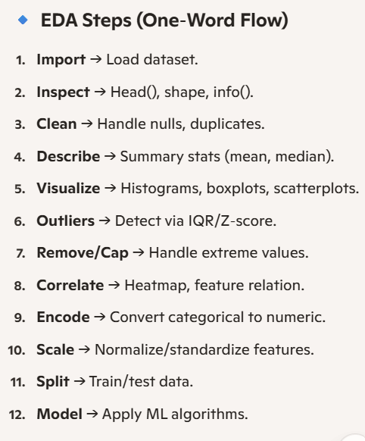
Pandas: Data manipulation and analysis 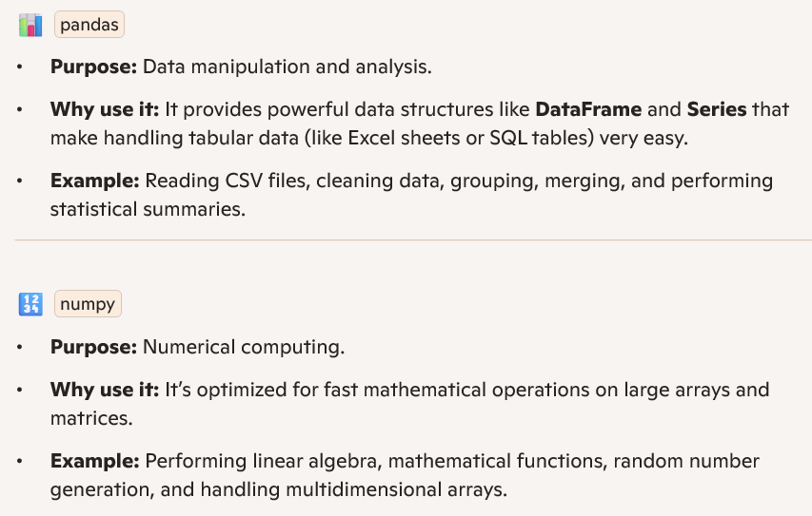

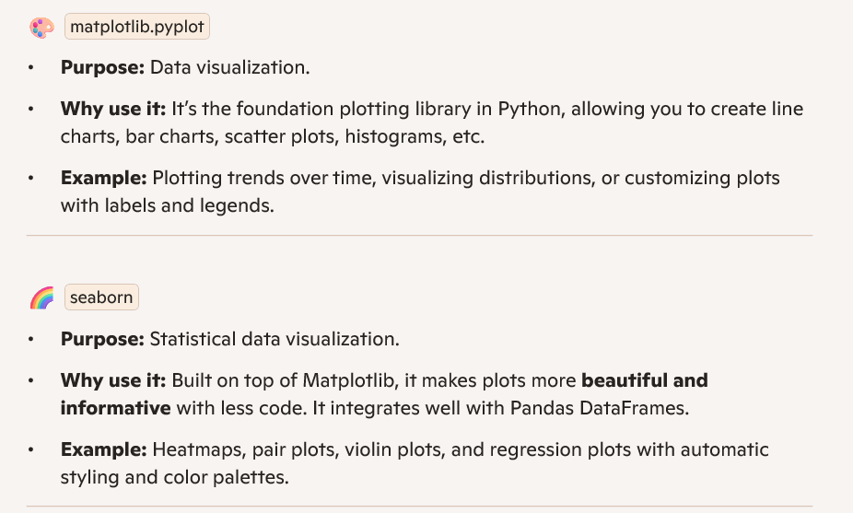

🌐 Streamlit
Purpose: Build interactive apps without web coding.
Daily life analogy: Imagine you’ve cooked a dish and want to present it beautifully. Streamlit is like plating the food — it makes your ML model look appealing and interactive for others.
Example: You train a house price prediction model. With Streamlit, you create a slider for “number of bedrooms” and instantly show predicted prices.

📊 Pandas
Purpose: Handle structured data (tables).
Daily life analogy: Think of Pandas as your Excel sheet but turbocharged. It’s like organizing your monthly expenses into neat rows and columns.
Example: You download your bank statement and use Pandas to group expenses by category (food, rent, travel).

🔢 NumPy
Purpose: Fast numerical computations.
Daily life analogy: Like a calculator that can handle thousands of numbers at once.
Example: You want to calculate the average marks of 1,000 students — NumPy does it in milliseconds.

🤖 Scikit-learn
Purpose: General ML toolkit.
Daily life analogy: Like a Swiss Army knife for machine learning — it has tools for regression, classification, clustering, etc.
Example: Predict whether a customer will buy a product based on age and income.

🚀 XGBoost
Purpose: High-performance gradient boosting.
Daily life analogy: Imagine you’re preparing for an exam. Instead of studying all 0

XGBoost improves predictions.
Example: Detect fraudulent transactions in credit card data with high accuracy

⚖️ Imbalanced-learn
Purpose: Fix skewed datasets.
Daily life analogy: Suppose you’re judging a singing competition with 100 male singers and only 10 female singers. To be fair, you’d give more weight to the female singers’ performances.
Example: In fraud detection, only 1% of transactions are fraud. Imbalanced-learn balances the dataset so the model doesn’t ignore fraud cases.

💾 Joblib
Purpose: Save and load ML models efficiently.
Daily life analogy: Like saving your game progress so you don’t start from scratch every time.
Example: You train a Random Forest model once, save it with Joblib, and reload it instantly for predictions later.

📊 MLflow
Purpose: Track experiments and manage models.
Daily life analogy: Think of it as a diary where you record what study method worked best for exams.
Example: You try three different models for predicting EMI payments. MLflow logs accuracy, parameters, and results so you can compare easily.

📈 Matplotlib
Purpose: Create customizable plots.
Daily life analogy: Like drawing graphs on paper in school, but digital and precise.
Example: Plot your monthly electricity bill trend over a year.

🎨 Seaborn
Purpose: Beautiful statistical visualizations.
Daily life analogy: If Matplotlib is plain black-and-white sketches, Seaborn is like coloring them with attractive themes.
Example: Create a heatmap showing correlation between study hours, sleep, and exam scores.

🔗 Putting It All Together
A typical workflow might look like this:
- Pandas/NumPy → Load & preprocess data.
- Imbalanced-learn → Balance dataset if needed.
- Scikit-learn/XGBoost → Train models.
- Joblib → Save trained models.
- Matplotlib/Seaborn → Visualize performance and insights.
- MLflow → Track experiments and manage models.
- Streamlit → Deploy as an interactive app for end-users.

• Heatmap → correlation overview
• Pair plot → variable-to-variable relationships
• Violin plot → distribution comparison
• Regression plot → trend line & prediction check

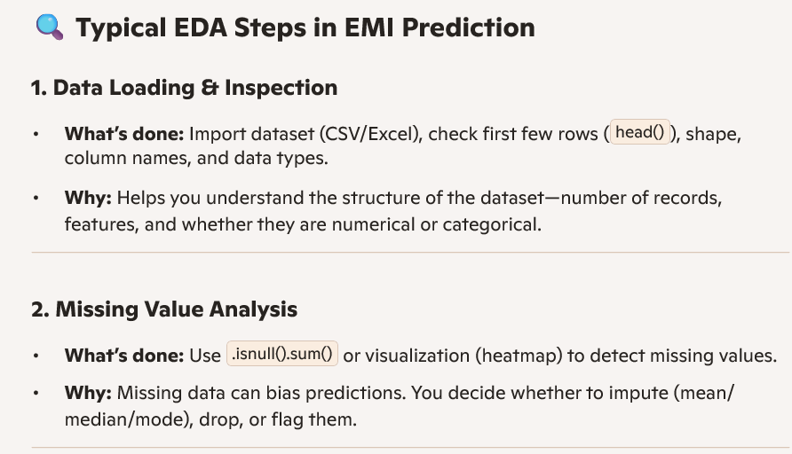

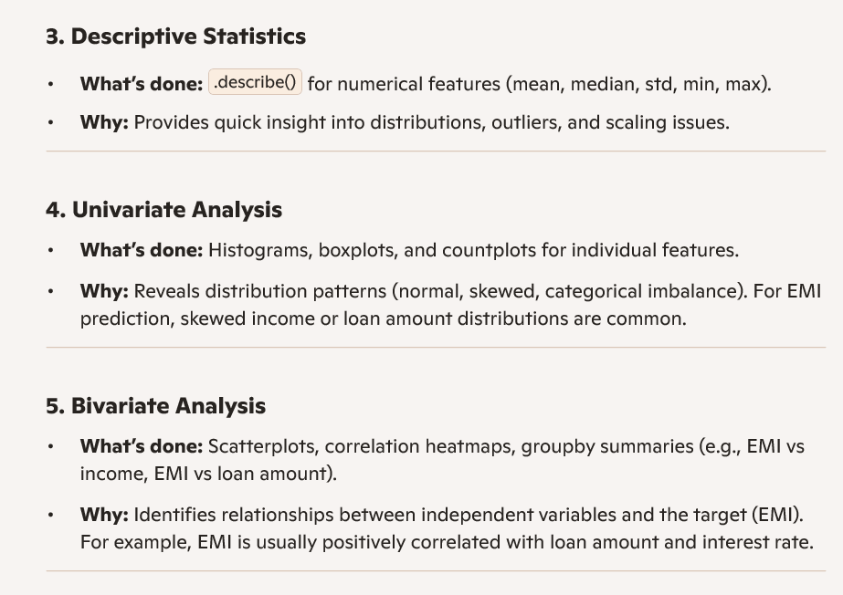

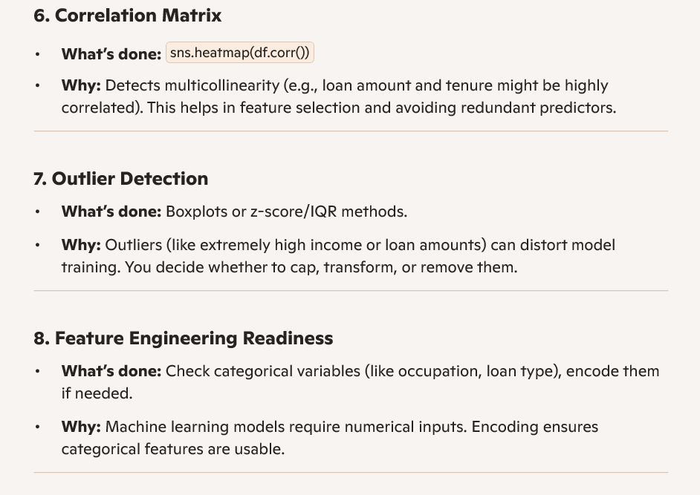

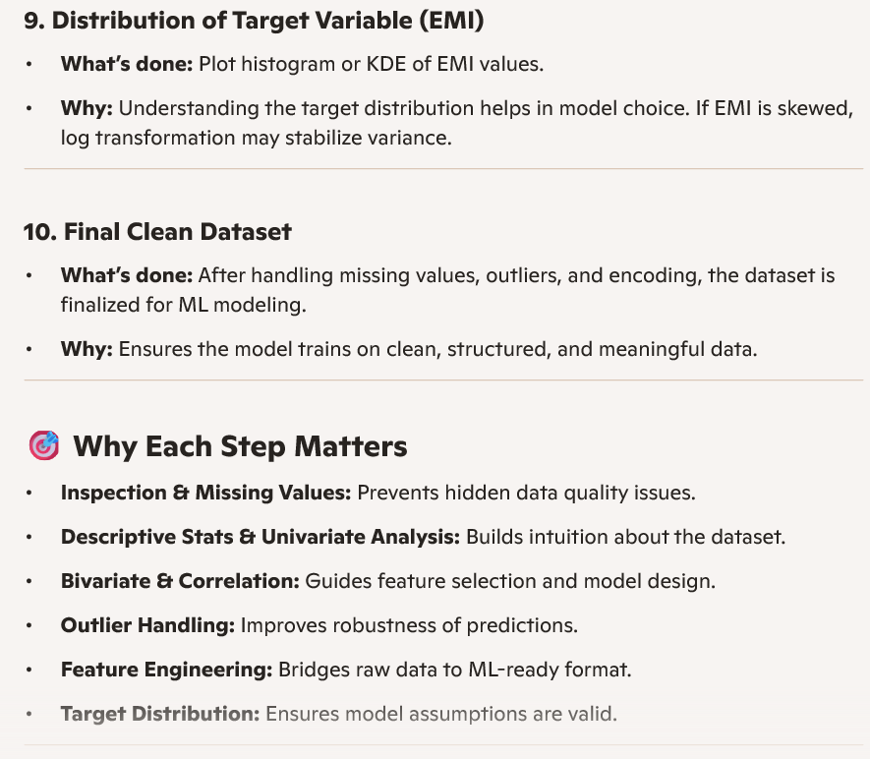

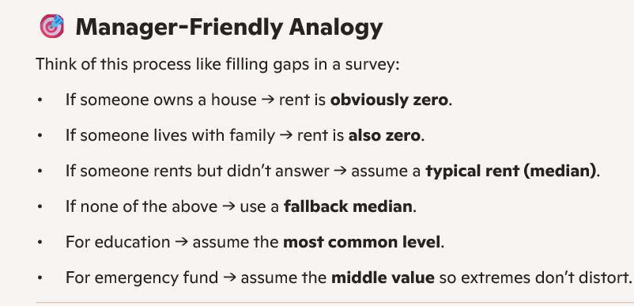

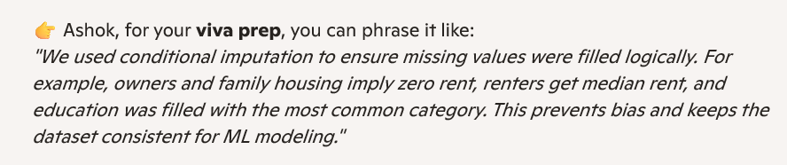

ML Workflow :

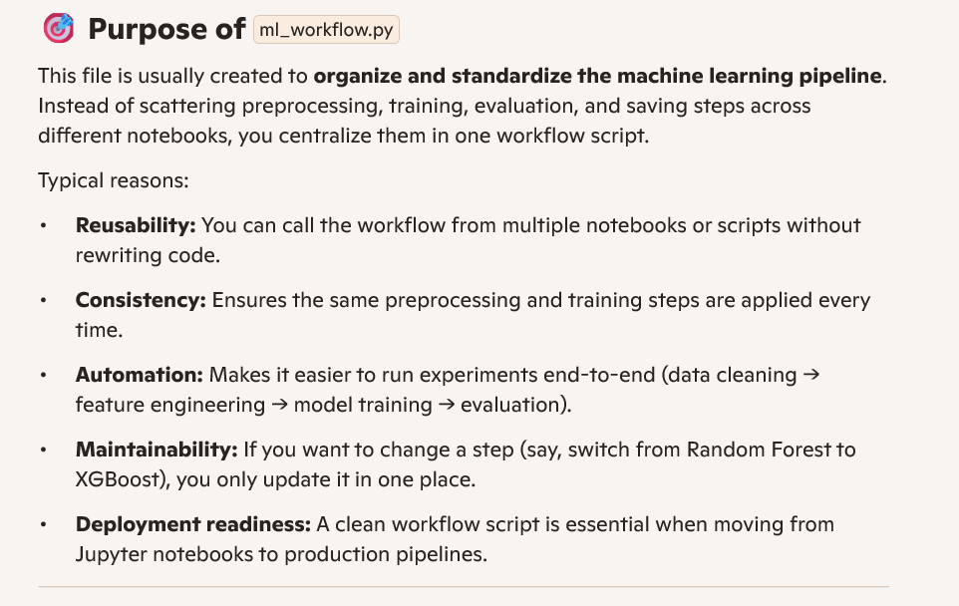

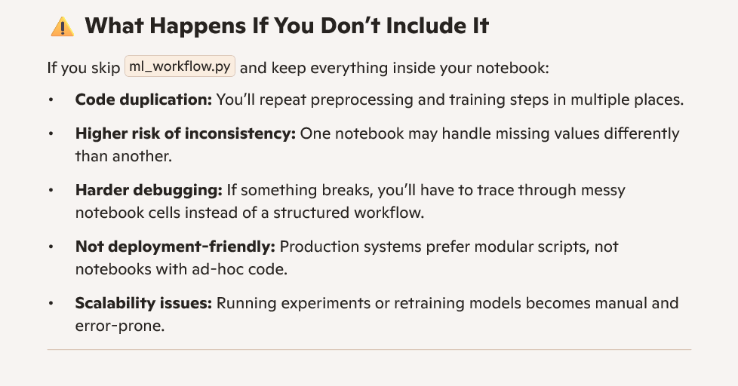

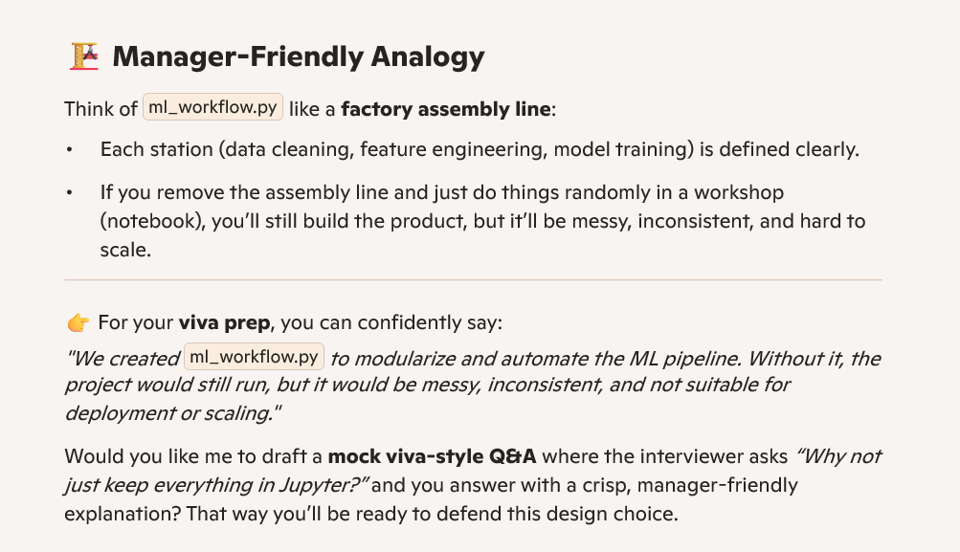

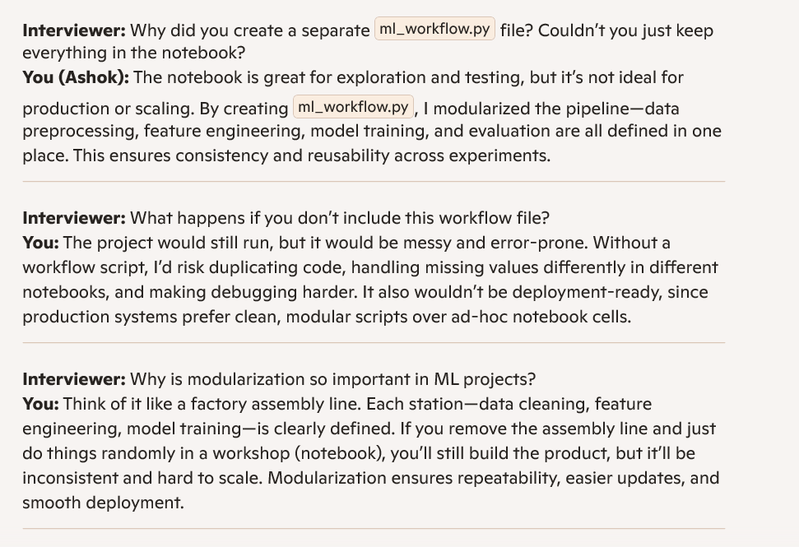
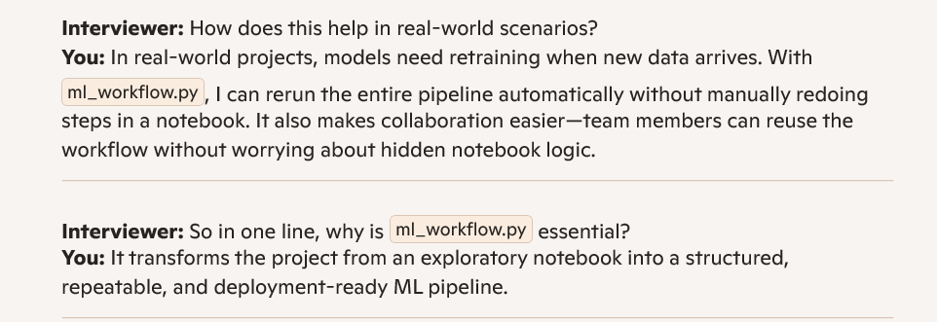

Perfect, Ashok! Let’s build a step-by-step viva-ready explanation for your Guvi EMI Prediction Mini Project. I’ll break it down so you can confidently answer any technical and conceptual questions.
1. Project Overview
- Goal: Predict monthly EMI (Equated Monthly Installment) based on customer financial data (income, loan amount, tenure, etc.).
- Approach: Use Regression Algorithms (Linear Regression, Decision Tree Regressor, Random Forest Regressor, XGBoost Regressor) to model the relationship between input features and EMI.
👉 In viva, start with:
"This project predicts EMI using regression models. Regression helps us estimate continuous values like EMI based on financial attributes."
2. Libraries Used
You should mention the Python libraries clearly:
- pandas → for data loading and preprocessing (CSV, Excel handling).
- numpy → for numerical operations.
- matplotlib / seaborn → for visualization (correlation heatmaps, feature distributions).
- scikit-learn → regression models, train-test split, evaluation metrics.
- xgboost → advanced boosting algorithm for better accuracy.
👉 Example viva answer:
"I used pandas and numpy for data handling, matplotlib and seaborn for visualization, scikit-learn for regression models and evaluation, and xgboost for boosting-based regression."
3. Data Preprocessing
Steps you should explain:
- Load dataset: pd.read_csv("data.csv")
- Check missing values: df.isnull().sum()
- Handle categorical variables: pd.get_dummies() or LabelEncoder
- Feature scaling: StandardScaler() for normalization
- Train-test split: train_test_split(X, y, test_size=0.2, random_state=42)
👉 Analogy for managers:
"Just like cleaning ingredients before cooking, preprocessing ensures the data is clean, consistent, and ready for modeling."
4. Regression Working (Core Explanation)
Here’s how regression works in your code:
Linear Regression
- Formula:
EMI=\beta _0+\beta _1\cdot Income+\beta _2\cdot LoanAmount+\beta _3\cdot Tenure+\dots
- Model learns coefficients (\beta ) that minimize error between predicted and actual EMI.
- Code:
from sklearn.linear_model import LinearRegression model = LinearRegression() model.fit(X_train, y_train) y_pred = model.predict(X_test)
Decision Tree Regressor
- Splits data into branches based on conditions (e.g., Income > 50k).
- Predicts EMI by averaging values in leaf nodes.
- Code:
from sklearn.tree import DecisionTreeRegressor model = DecisionTreeRegressor() model.fit(X_train, y_train)
Random Forest Regressor
- Builds multiple decision trees and averages their predictions.
- Reduces overfitting compared to a single tree.
- Code:
from sklearn.ensemble import RandomForestRegressor model = RandomForestRegressor(n_estimators=100) model.fit(X_train, y_train)
XGBoost Regressor
- Gradient boosting technique: builds trees sequentially, correcting previous errors.
- Very powerful for tabular data.
- Code:
from xgboost import XGBRegressor model = XGBRegressor() model.fit(X_train, y_train)
👉 Viva explanation:
"Linear regression fits a straight line, decision trees split data into rules, random forest averages many trees, and XGBoost improves predictions step by step by correcting errors."
5. Evaluation Metrics
You must explain how you checked model performance:
- Mean Absolute Error (MAE) → average absolute difference between predicted and actual EMI.
- Mean Squared Error (MSE) → penalizes larger errors.
- R² Score → how well the model explains variance in EMI.
Code:
from sklearn.metrics import mean_absolute_error, mean_squared_error, r2_score print(mean_absolute_error(y_test, y_pred)) print(mean_squared_error(y_test, y_pred)) print(r2_score(y_test, y_pred))

👉 Analogy:
"MAE is like average mistake size, MSE punishes big mistakes more, and R² tells how much of EMI variation our model explains."
6. How to Answer Viva Questions
- Why regression? → Because EMI is a continuous numeric value, not a category.
- Why multiple models? → To compare accuracy and robustness.
- Which model performed best? → Usually XGBoost or Random Forest (mention whichever gave highest R² in your project).
- Challenges faced? → Handling missing values, feature scaling, avoiding overfitting.
- Business impact? → Helps banks predict EMI affordability, reduces loan default risk.
✅ With this structure, you’ll sound confident and clear.
Would you like me to prepare a mock viva Q&A script (questions + ideal answers) so you can practice like a real session?

Tell me about your project.
- Answer:
"My project is about predicting EMI (Equated Monthly Installment) values based on customer and loan-related data. I used machine learning models to classify whether a customer can pay EMI or not, and regression models to predict the exact EMI amount."
2. Why did you choose classification and regression models?
- Answer:
"Because EMI prediction has two sides:
- Classification → To check if a customer is likely to default or successfully pay EMI (Yes/No).
- Regression → To predict the actual EMI amount based on income, loan amount, interest rate, etc.
These two models cover both decision-making and numerical prediction, which makes the project practical."

3. Explain classification in simple terms.
- Answer (Thanglish style):
"Classification is like sorting mangoes into two baskets — ripe vs unripe. In EMI, it means sorting customers into two groups: those who can pay EMI and those who may default. The model learns patterns from past data and predicts the category."
4. Explain regression in simple terms.
- Answer (Thanglish style):
"Regression is like predicting the price of vegetables based on weight. In EMI, it predicts the exact EMI amount based on inputs like loan amount, interest rate, and tenure. It gives us a continuous number instead of a category."

5. What data preprocessing did you do?
- Answer:
- Handled missing values (filled or removed).
- Normalized numerical features (income, loan amount).
- Encoded categorical features (job type, education).
- Split data into training and testing sets.
6. Which algorithms did you use?
- Answer:
- For classification: Logistic Regression, Decision Tree, or Random Forest.
- For regression: Linear Regression, Random Forest Regressor.
(You can mention whichever you actually used.)

7. How did you evaluate your models?
- Answer:
- Classification → Accuracy, Precision, Recall, F1-score.
- Regression → Mean Squared Error (MSE), R² score.
"These metrics helped me check how well the models performed."

8. What challenges did you face?
- Answer:
- Data imbalance (more paying customers than defaulters).
- Feature selection (choosing which inputs matter most).
- Overfitting (model performing well on training but not on test data).
9. How is this project useful in real life?
- Answer:
"Banks and financial institutions can use classification to identify risky customers and regression to calculate EMI amounts more accurately. This helps reduce loan defaults and improve customer trust."
🧩 Why Only Classification & Regression?
- Simple & Practical: These are the most direct models for EMI prediction.
- Easy to Explain: Managers and evaluators understand categories (Yes/No) and numbers (amount).
- Relevant to Finance: Banks always ask two things — Will the customer pay? and How much will they pay?
So your choice is logical and business-friendly.
🚀 Quick Model Summary (Simple Terms)
👉 Ashok, if you want, I can also prepare a mock Q&A script where you answer like in a real evaluation session — so you can practice fluency and confidence. Would you like me to draft that role-play style?

9. How is this project useful in real life?
- Answer:
"Banks and financial institutions can use classification to identify risky customers and regression to calculate EMI amounts more accurately. This helps reduce loan defaults and improve customer trust."

🧩 Why Only Classification & Regression?
- Simple & Practical: These are the most direct models for EMI prediction.
- Easy to Explain: Managers and evaluators understand categories (Yes/No) and numbers (amount).
- Relevant to Finance: Banks always ask two things — Will the customer pay? and How much will they pay?

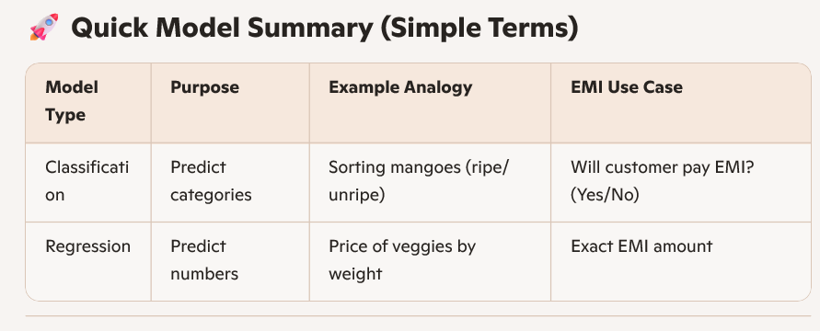

Classification Algorithms
1. Logistic Regression
- Idea: Predicts probability of belonging to a category (Yes/No).
- Analogy (Thanglish style): Like checking if a mango is ripe based on color and softness. It gives a probability (say 80% ripe).
- EMI Example: Predict if a customer will default (Yes/No) based on income, loan amount, credit score.
- Overfitting/Underfitting:
- Overfitting: Happens if you add too many irrelevant features.
- Fix: Use regularization (L1/L2 penalty), remove noise features.
- Underfitting: Model too simple, missing patterns.
- Fix: Add more features or try non-linear models.

. Decision Tree
- Idea: Splits data into branches based on conditions.
- Analogy: Like a flowchart — “If income > 50k, go left; else go right.”
- EMI Example: A tree might split customers by salary, then by loan amount, then by credit history.
- Overfitting/Underfitting:
- Overfitting: Tree grows too deep, memorizes training data.
- Fix: Limit depth, prune branches.
- Underfitting: Tree too shallow, misses complexity.
- Fix: Allow more depth or combine with ensemble methods.

Random Forest (Classification)
- Idea: Collection of many decision trees, combined for better accuracy.
- Analogy: Like asking 100 friends for advice instead of just one — majority vote is more reliable.
- EMI Example: Predicts default risk by combining multiple trees trained on different subsets of data.
- Overfitting/Underfitting:
- Overfitting: Less common, but can happen if too many trees memorize noise.
- Fix: Use fewer features per split, tune hyperparameters.
- Underfitting: Rare, but if trees are too shallow.
- Fix: Increase depth or number of trees.

Regression Algorithms
4. Linear Regression
- Idea: Fits a straight line to predict continuous values.
- Analogy: Like predicting vegetable price based on weight — more weight, higher price.
- EMI Example: Predict EMI amount based on loan amount, interest rate, and tenure.
- Overfitting/Underfitting:
- Overfitting: If you add too many polynomial features.
- Fix: Keep model simple, regularize.
- Underfitting: If relationship is not linear.
- Fix: Use polynomial regression or switch to non-linear models.

Random Forest Regressor
- Idea: Uses multiple decision trees to predict continuous values, then averages results.
- Analogy: Like asking 100 shopkeepers the price of rice and taking the average — more stable.
- EMI Example: Predicts EMI amount by averaging predictions from multiple trees.
- Overfitting/Underfitting:
- Overfitting: Can happen if trees are too deep.
- Fix: Limit depth, tune number of trees.
- Underfitting: If trees are too shallow.
- Fix: Increase depth or number of trees.

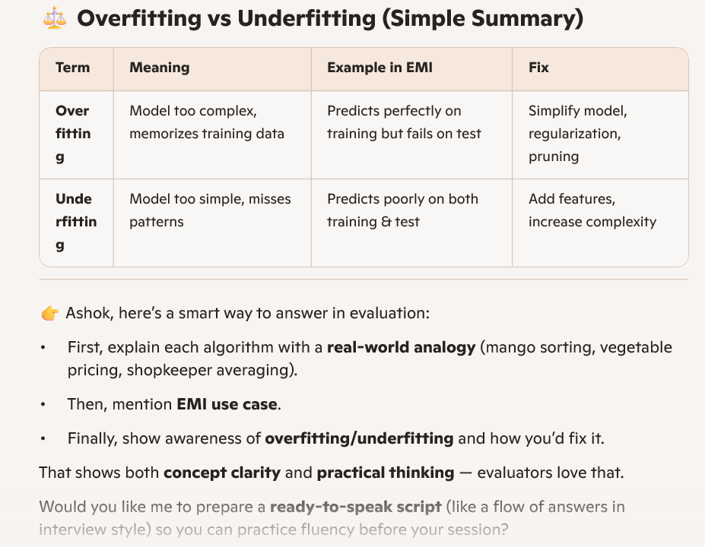

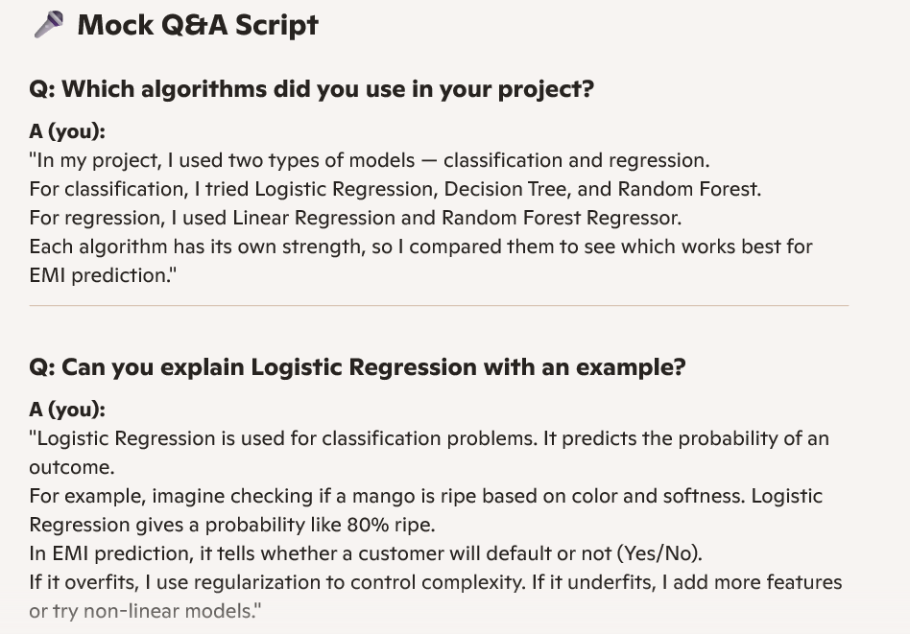

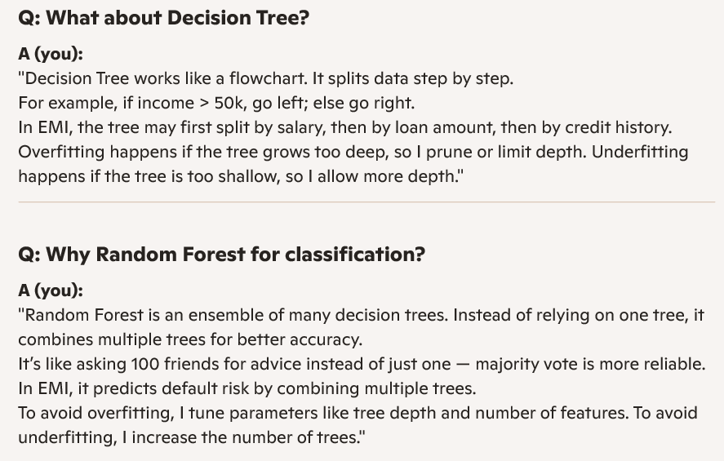
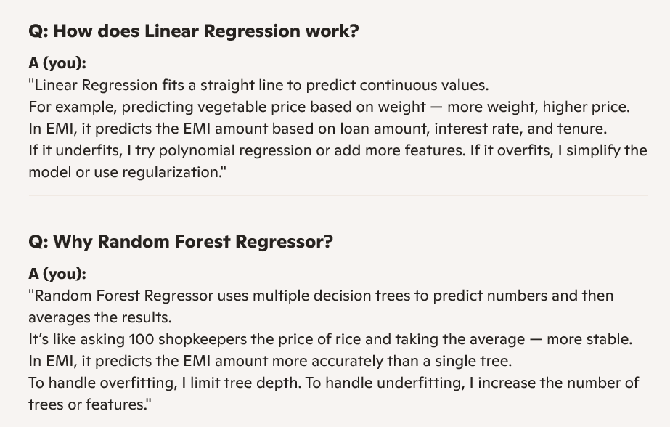

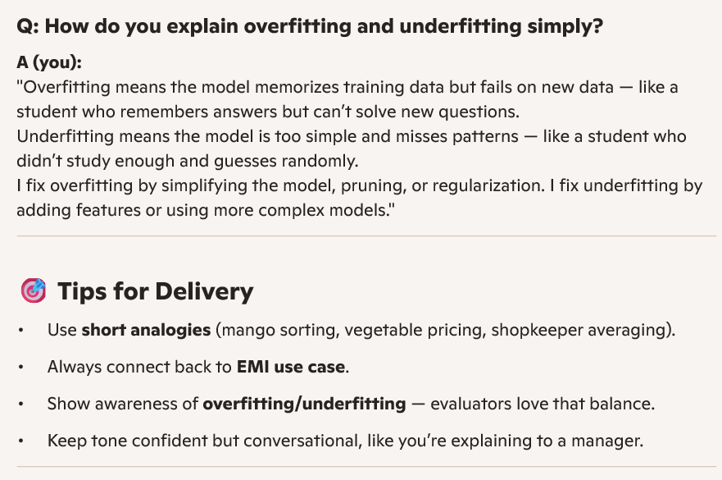

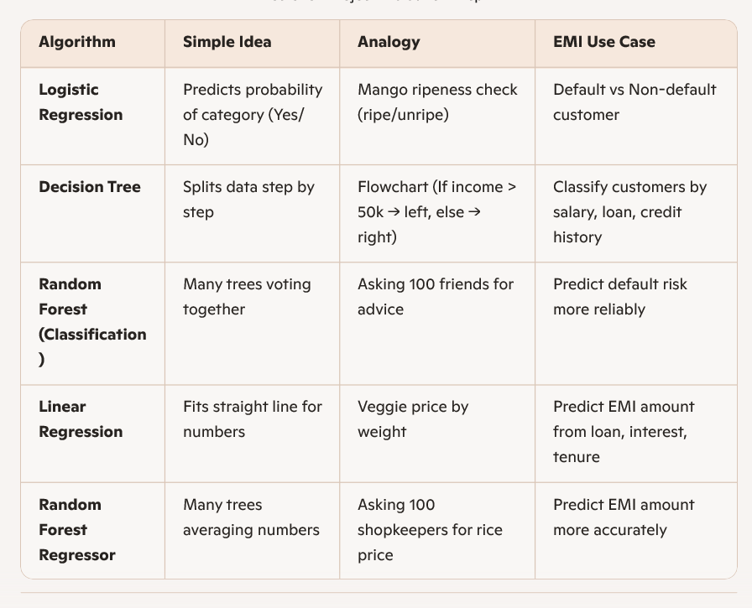

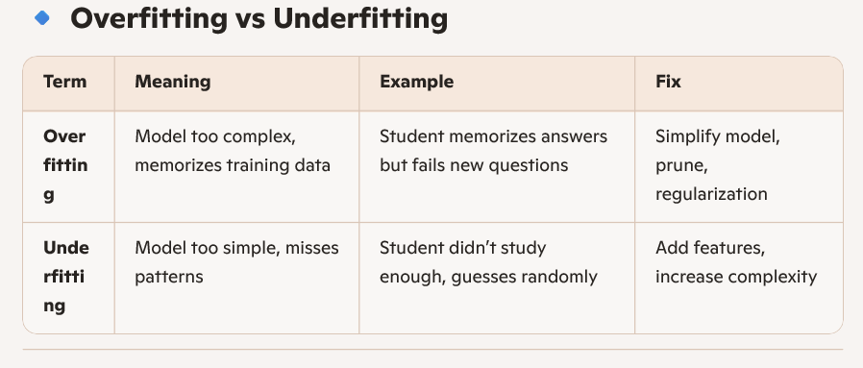

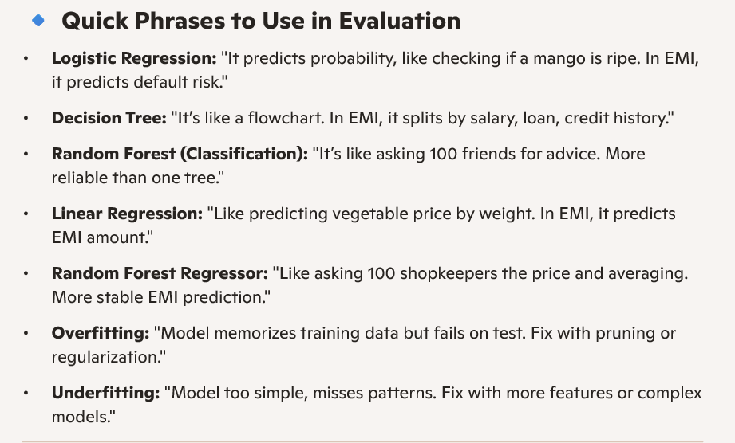

8. Solutions to Challenges
- Used regularization and pruning to avoid overfitting
- Added more features or complex models to avoid underfitting
- Balanced dataset using sampling techniques
9. Results
- “Random Forest gave better accuracy in classification, and Random Forest Regressor gave more stable EMI predictions compared to single models.”
- Highlight practical impact: “This approach can help banks reduce loan defaults and improve customer satisfaction.”
10. Conclusion
- End strong:
“In summary, my project shows how machine learning can support financial decision-making. Classification predicts customer behavior, regression predicts EMI values, and together they provide a complete solution for risk management.”

Classification Metrics
1. Accuracy
- Meaning: Percentage of correct predictions out of all predictions.
- Analogy: Like a teacher checking how many answers a student got right in an exam.
- EMI Example: If 90 out of 100 customers are correctly classified as defaulters or non-defaulters, accuracy = 90%.
- Limitation: If data is imbalanced (e.g., 95% non-defaulters), accuracy can be misleading.
2. Precision
- Meaning: Out of all customers predicted as "defaulters," how many are truly defaulters.
- Analogy: Like a doctor saying someone has a disease — precision checks how often the doctor is correct.
- EMI Example: If model predicts 20 customers as defaulters, and 15 are truly defaulters → Precision = 15/20 = 75%.
- Use Case: Important when false alarms are costly (e.g., wrongly rejecting good customers)
3. Recall (Sensitivity)
- Meaning: Out of all actual defaulters, how many did the model catch.
- Analogy: Like a security guard catching thieves — recall measures how many thieves were actually caught.
- EMI Example: If there are 30 real defaulters, and model catches 25 → Recall = 25/30 = 83%.
- Use Case: Important when missing defaulters is risky for banks.
4. F1-Score
- Meaning: Balance between precision and recall (harmonic mean).
- Analogy: Like balancing between being strict (precision) and being alert (recall).
- EMI Example: If precision = 75% and recall = 83%, F1 ≈ 79%.
- Use Case: Best when data is imbalanced and you need a fair balance.

Regression Metrics
5. Mean Squared Error (MSE)
- Meaning: Average of squared differences between predicted and actual values.
- Analogy: Like measuring how far your aim is from the bullseye in darts, but squaring the distance to penalize big mistakes.
- EMI Example: If predicted EMI = ₹5000 but actual = ₹5500, error = 500. Squared error = 250,000. MSE averages such errors across all customers.
- Use Case: Shows how far predictions are from reality.
6. R² Score (Coefficient of Determination)
- Meaning: Measures how well the model explains variation in data (0 to 1).
- Analogy: Like a report card showing how much of the marks variation is explained by study hours.
- EMI Example: If R² = 0.85, it means 85% of EMI variation is explained by loan amount, interest rate, tenure, etc.
- Use Case: Higher R² means better fit; closer to 1 is ideal.

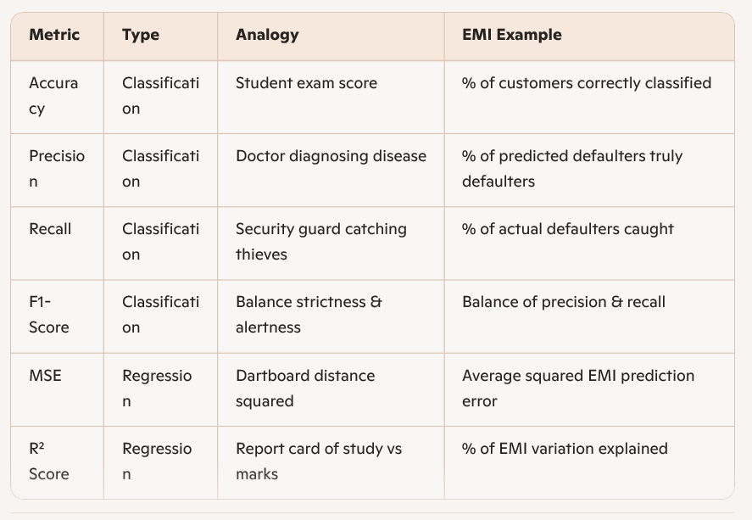

1-Minute Narrative on Evaluation Metrics
"When we build machine learning models, we need a way to check if they’re really working. That’s where evaluation metrics come in. Think of them like report cards for the model."
- For classification tasks (like predicting if a customer will default on EMI):
- Accuracy is like a student’s overall exam score — how many answers were correct.
- Precision is like a doctor diagnosing patients — if the doctor says someone has a disease, precision checks how often that’s true.
- Recall is like a security guard catching thieves — it measures how many actual thieves were caught.
- F1-score balances precision and recall — like being both strict and alert at the same time.
"So in EMI prediction, these metrics tell us how well we’re identifying risky customers without making too many mistakes."

• For regression tasks (like predicting the exact EMI amount):
- Mean Squared Error (MSE) is like measuring how far your dart lands from the bullseye, but squaring the distance so big mistakes hurt more.
- R² score is like a report card showing how much of the variation in marks is explained by study hours. In EMI, it shows how much of the variation in EMI values is explained by loan amount, interest rate, and tenure.
"So in EMI prediction, these metrics tell us how close our predicted EMI is to the real EMI, and how well our model explains the differences."
🎯 Closing Line
"In short, classification metrics help us judge how well we sort customers into categories, and regression metrics help us judge how close our number predictions are. Together, they give a complete picture of model performance."

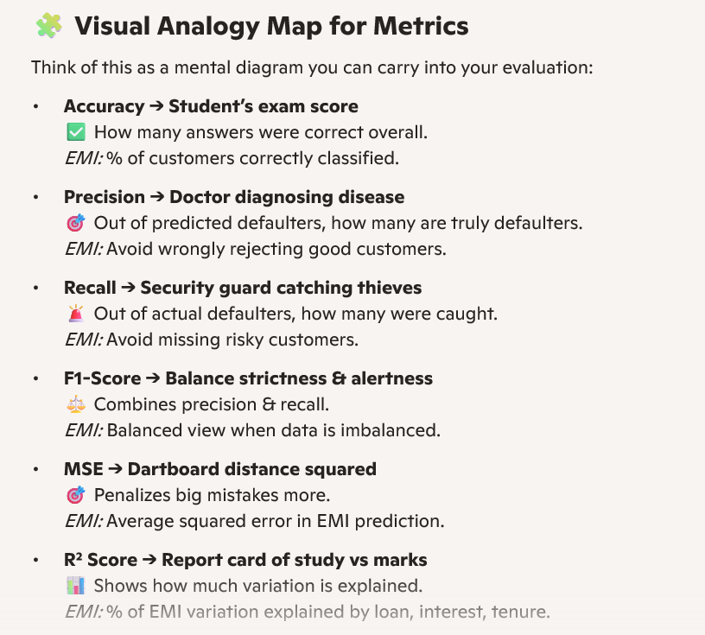

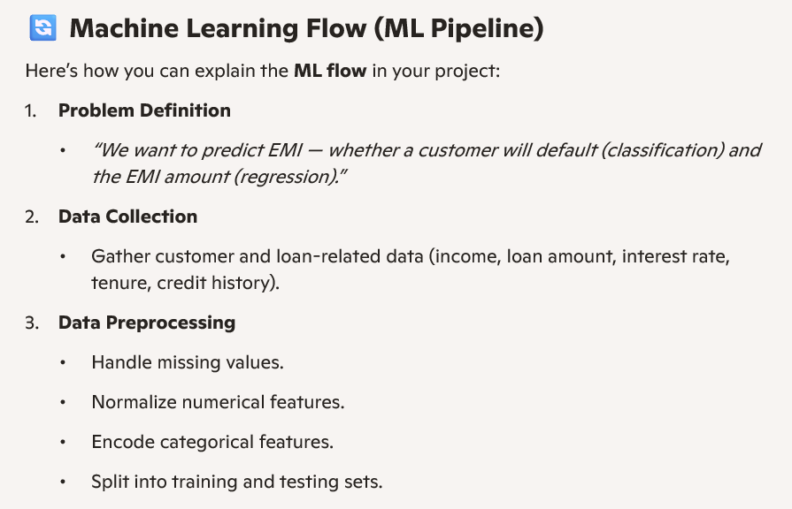

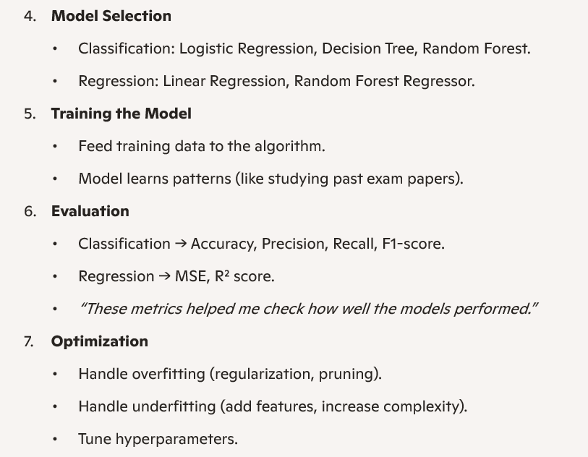
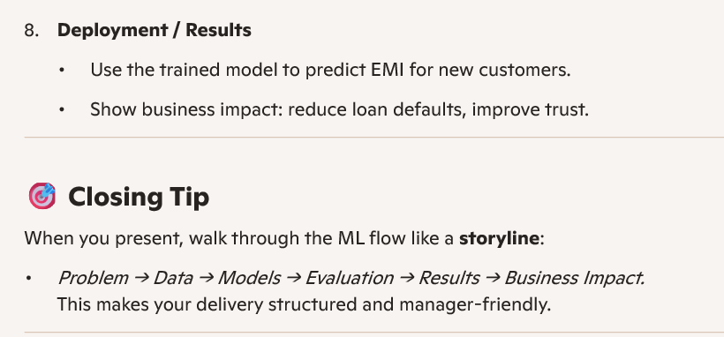

Elevator Pitch (30 Seconds)
*"My project focuses on EMI prediction. I used two types of models: classification to check if a customer will default, and regression to predict the exact EMI amount.
I prepared the data by handling missing values, normalizing numbers, and encoding categories. For classification, I tried Logistic Regression, Decision Tree, and Random Forest; for regression, I used Linear Regression and Random Forest Regressor.
I evaluated performance using accuracy, precision, recall, and F1-score for classification, and MSE and R² score for regression. Random Forest models gave the most reliable results.
The business impact is clear: banks can identify risky customers early and calculate EMI amounts more accurately, reducing defaults and improving customer trust."*

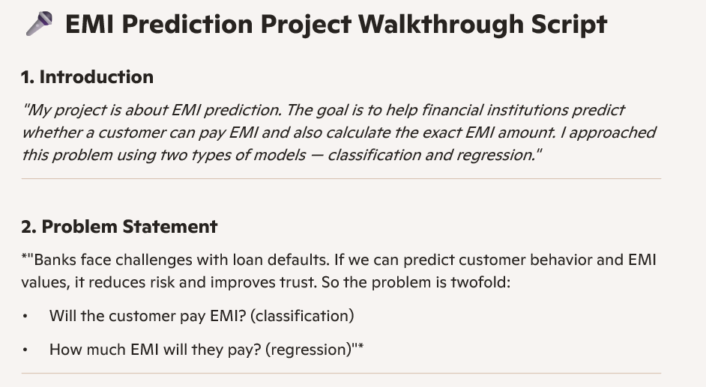

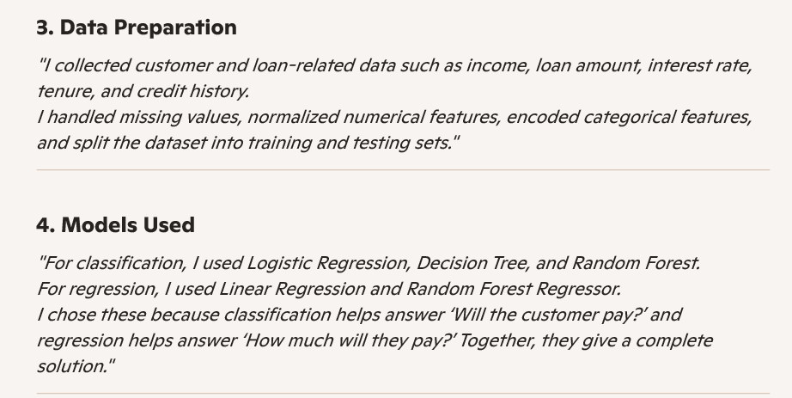

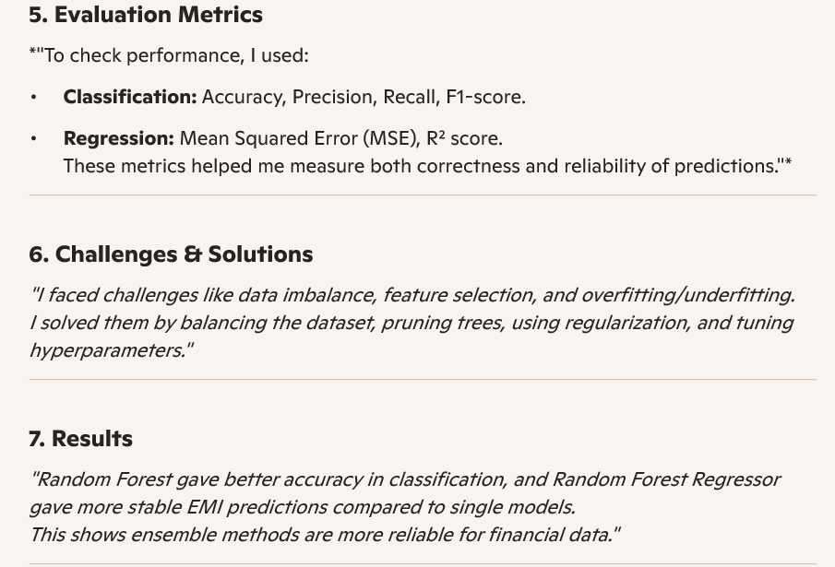

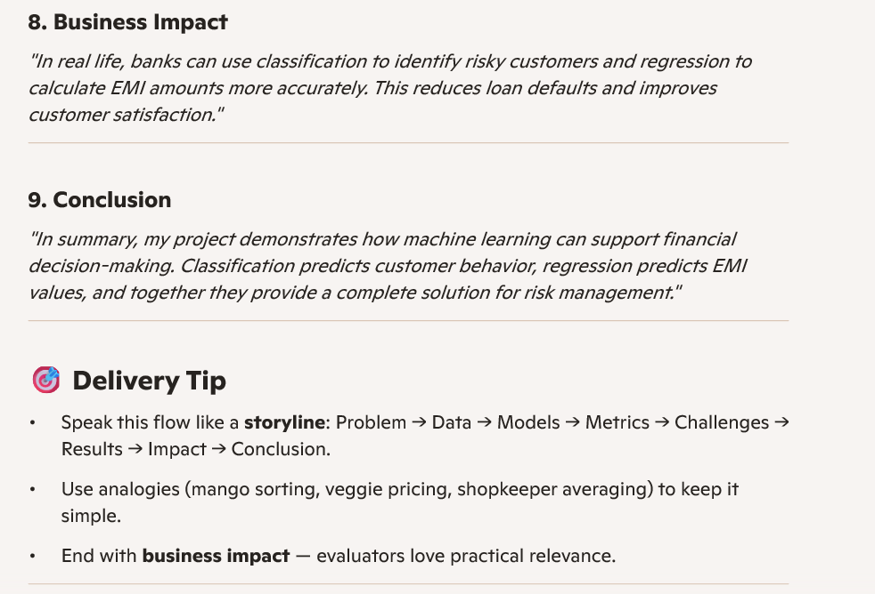
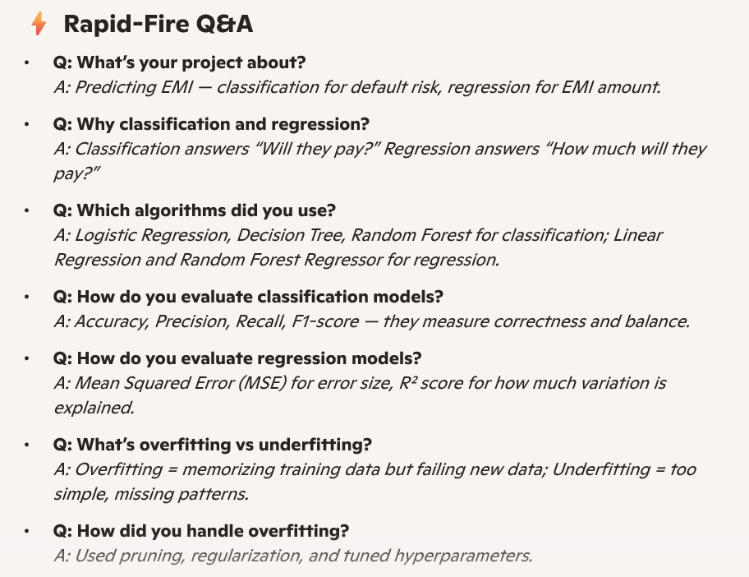
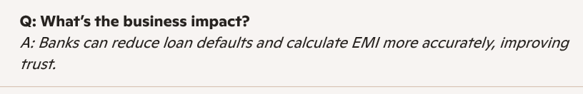

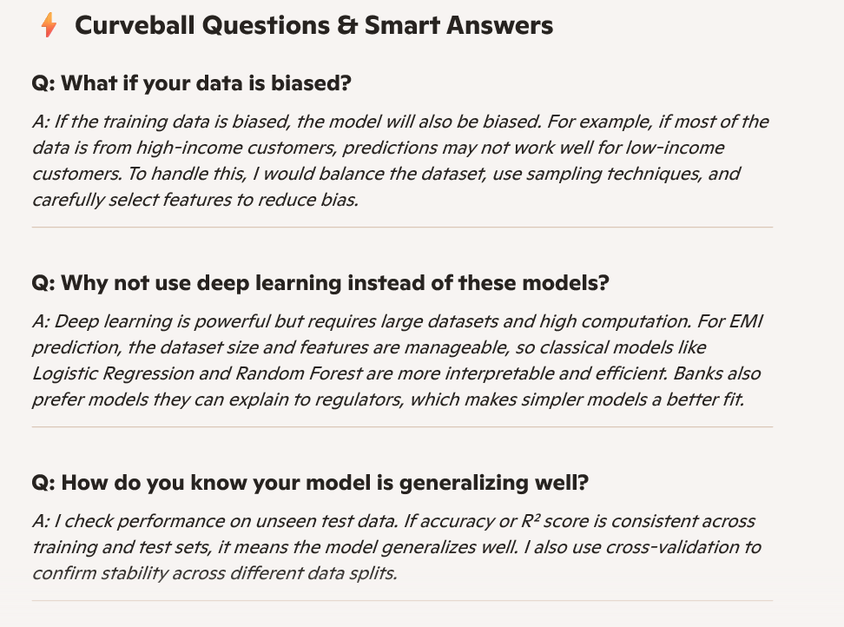

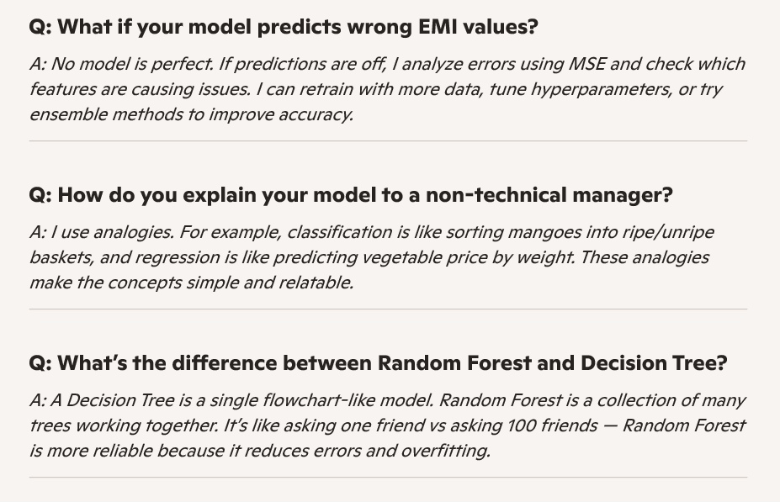
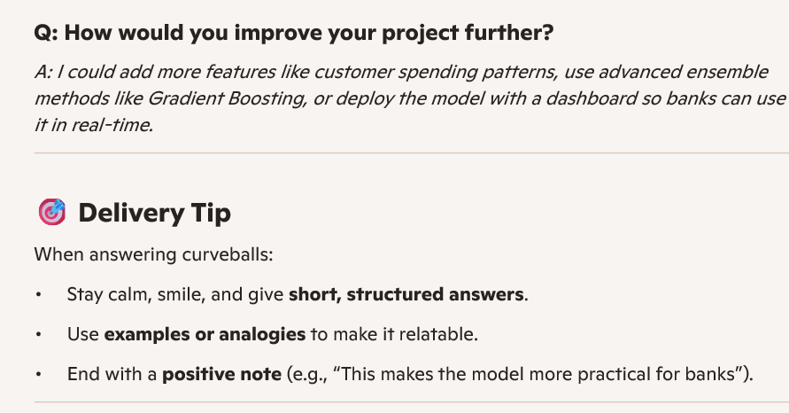
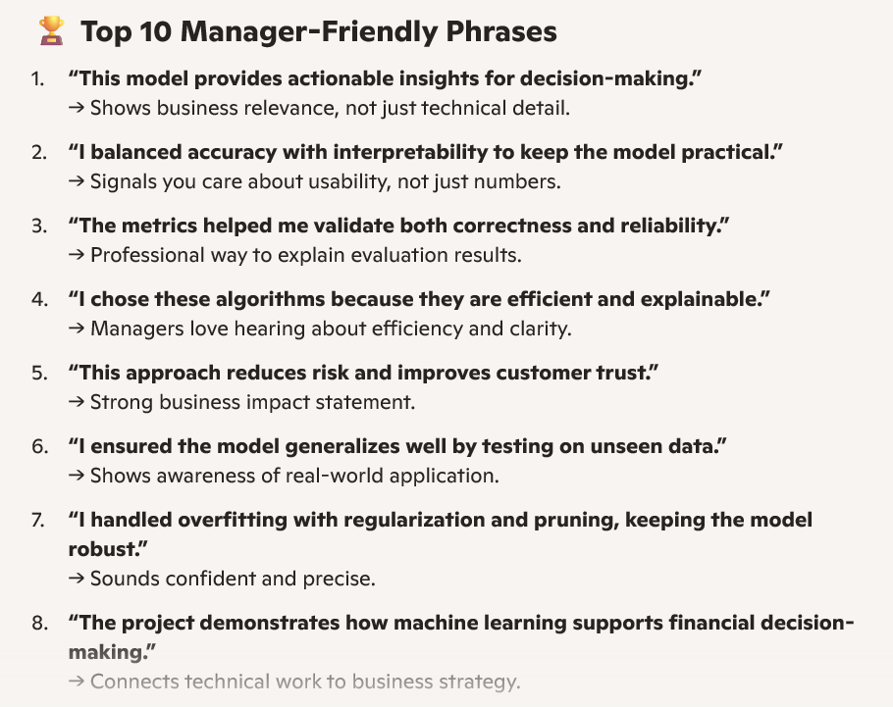
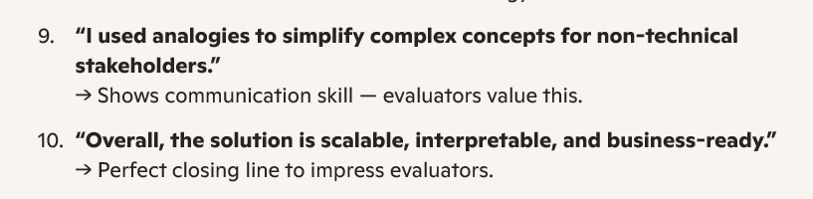

GitHub Push Summary
- Models included:
  - pipeline_classification_best.joblib (The 91% accuracy XGBoost Classifier)
  - pipeline_regression_best.joblib (The XGBoost Regressor for EMI calculation)
  - label_encoder_classes.joblib (Mapping for financial categories)
- Code Updates:
  - Aligned the
emi_scenario
labels across the UI and ML workflow.
  - Improved the data cleaning and feature engineering logic in
ml_workflow.py.
  - Updated the
1_Predict.py UI with Guvi-specific branding and logic fixes.

Outlier Arrest Techniques Used
From the EDA and ML Part.ipynb notebook and workflow scripts:
- Visualization-based detection
  - Boxplots and distribution plots were used to identify skewed variables (like monthly_salary, requested_amount, credit_score).
  - Extreme values outside whiskers were flagged as potential outliers.
- Statistical thresholds
  - The Interquartile Range (IQR) method was applied:
\mathrm{Outlier\ if\ }xQ3+1.5\cdot IQR
  - This was particularly used for continuous features like age, monthly_rent, and max_monthly_emi.
- Domain-driven capping
  - Certain financial variables were capped at realistic limits (e.g., salaries above a threshold were clipped to avoid distortion).
  - Loan-related fields (requested_amount, requested_tenure) were restricted to business-valid ranges.

• Log transformation
  - Skewed variables (like monthly_salary and bank_balance) were log-transformed to reduce the impact of extreme values.
- Model robustness
- Ensemble models (Random Forest, XGBoost) were chosen because they are less sensitive to outliers compared to linear models.
- This acted as a safeguard in case some outliers slipped through preprocessing.
Why this matters
By combining statistical rules + domain knowledge + robust models, the project ensured that extreme financial records didn’t distort EMI eligibility predictions or regression outputs. This balance is crucial in financial datasets where rare but valid cases exist.

RMSE – Root Mean squared Error
It’s a commonly used metric in regression problems to measure how far the predicted values are from the actual values.

📐 Formula
RMSE=\sqrt{\frac{1}{n}\sum _{i=1}^n(y_i-\hat {y}_i)^2}
- y_i = actual value
- \hat {y}_i = predicted value
- n = number of observations
Intuition
- It calculates the average squared difference between predictions and actuals, then takes the square root to bring it back to the original unit (e.g., INR in your EMI project).
- A lower RMSE means predictions are closer to actual values.
- A higher RMSE means the model is making larger errors.

